FUNCTIONAL SPECIFICATION – EMEA AEO desk tool
1. Purpose & Scope 1
2. Rights & Permissions 1
2.1 User Roles 1
2.2 Role Permissions 1
2.3 Visibility Rules in the questionnaire 2
3. Entrance & Navigation 2
3.1 Entry Point 2
3.2 Country-Based Navigation 3
4. Main Functions 3
4.1 Questionnaire Setup 3
4.2 Filtering options 5
4.3 Assessment Launch 5
4.4 Responder Actions 6
4.5 Review & Approval Workflow 6
4.6 Functional buttons within the tool 7
4.7 Notifications & Automation 7
5. Database & Data Management 8
5.1 Database Structure 8
5.2 Historical Data 8
5.4 Data Transfer & Archive 8
6. Reporting potential 8
7. Version History 9

1. Purpose & Scope
This document describes the functional requirements of the EMEA AEO Desk Tool.
The specification is intended for the IT development team to design, build and test the solution.
The tool supports EMEA GTOC Excellence and GCA teams in managing country questionnaires in a controlled and semi-automated manner.

2. Rights & Permissions

2.1 User Roles
The system shall support four distinct user roles:
- Level 1: Admin - Daria Kovalenko and Nishant Grover
- Level 2: Assessment Lead (AL) – GTOC Excellence & GCA Assessment Leads listed per country with access to all countries
- Level 3: Responder (R) - Country respondents assigned in questions
- Level 4: GTC EMEA Leaders - Luis Loaiza and Tom McGroder

Country | Assessment leads (AL)
 | GTOC Excellence | GCA
Netherlands | Cas ter Heide | Lars Jacobsson
Italy | Elena Sogaro | Nicoletta Fiorentini
France | Doria HAMAK | Evelyne Mechant
Spain | Jessica Sanchez Lima  Juan Ignacio Zuin | Nicoletta Fiorentini
Turkey | Merve Saygan | Samira Huseyn
Germany | Maximilian Thannbichler (GCA acts as Excellence) | Nicoletta Fiorentini
Belgium | Onur Yoldemir | Evelyne Mechant
Poland | Nikita Larionov | Kamilla Lipinska

2.2 Role Permissions
Permissions shall be enforced by role and country assignment.
- Admin:
Full system administration privileges
- Assessment Lead (AL):
Responsible for launching assessments; managing questions, responders, BU & entities (adding, editing, or removing as needed); reviewing and approving responses; providing comments; requesting corrections; and finalizing assessments for assigned countries, access to database, including tool reporting functionality.
Important aspect: AL can also act as a Responder, but that should not change their role and permission.
- Responder (R):
Access limited to assigned questions only. Can submit responses, upload attachments, and add comments. No visibility into other countries and no database or reporting functionalities access.
- GTC EMEA Leaders:
Read-only access to all content, including tool reporting functionality and database

2.3 Visibility Rules in the questionnaire
Responders shall only see questions explicitly assigned to them.
For some countries, Responder (R) should not see each other’s answers when the same question is assigned in different tabs. France is here as an example.
Important aspect: Exception is If AL is a Responder as well
Assessment Leads, Admins, GTC EMEA Leaders shall see all content for all countries.

3. Entrance & Navigation

3.1 Entry Point
Users shall access the tool via authenticated corporate login.
Country-based navigation shall be enforced immediately after logging in.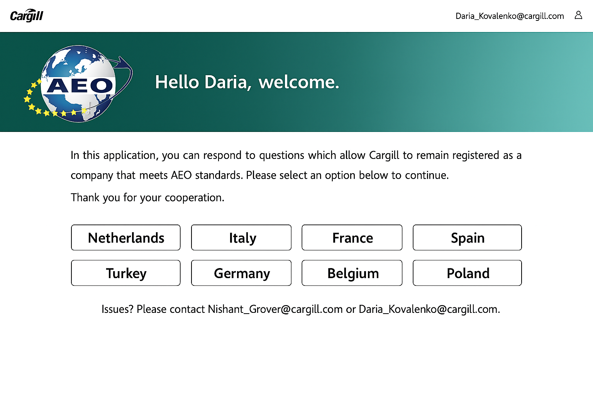

3.2 Country-Based Navigation
Responders shall access only their own country.

4. Main Functions

4.1 Questionnaire Setup
Tool support questions in local language and English translation.
All other feature of the tool only in English version.
The front page of the questionnaire once you enter the country consists of:
- Top banner describing country ALs, deadline, BU and/or entities in scope.
- Home button
- Filtering options (logic description in 4.2. chapter of this document)
- Database button
- Right side: Chapter & Sub-Chapter and in the bracket total quantity only of Chapters.
- Left side: Question and in the bracket total quantity questions
Each chapter, sub-chapter, questions shall have a unique ID number.
The above picture represents already Launched assessment.
Launch process described in 4.3. chapter of this document.
Country | Assessment leads (AL) |  | Language | Deadline
Netherlands | Cas ter Heide | Lars Jacobsson | English | 31/12
Italy | Elena Sogaro | Nicoletta Fiorentini | Local & English | 31/07
France | Doria HAMAK | Evelyne Mechant | Local & English | 31/12
Spain | Jessica Sanchez Lima  Juan Ignacio Zuin | Nicoletta Fiorentini | Local & English | 31/07
Turkey | Merve Saygan | Samira Huseyn | Local & English | 31/01
Germany | Maximilian Thannbichler | Nicoletta Fiorentini | Local & English | 31/12
Belgium | Onur Yoldemir | Evelyne Mechant | Local & English | 31/05
Poland | Nikita Larionov | Kamilla Lipinska | English | 30/06

Country | BU & entities in scope
Netherlands ** | CAN - Provimi BV  CASC - Cargill BV  CCC - Cargill BV  CPAE - Cargill Meats Holland BV  CSST - Cargill BV  CTS - Cargill BV  EOE - Cargill BV  PT - Cargill Bioindustrial BV  ZOR - Cargill BV
Italy | CASC - Cargill SRL
France ** | CSST - Cargill Haubourdin SAS  CPE - Cargill Foods France
Spain | CSST - Cargill SLU  CAN - Cargill SLU  GEOS - Cargill SLU  CASC - Cargill SLU
Turkey | CSST - Cargill Tarim  GEOS - Cargill Tarim  CBI - Cargill Tarim  CAN - Cargill Tarim
Germany | CSST - Cargill Texturizing Solutions Deutschland GmbH & Co. KG  CSST - Cargill Deutschland GmbH  CCC - Cargill GmbH  GEOS - Cargill GmbH  CASC - Cargill GmbH  BIODIESEL - Cargill GmbH
Belgium ** | CAN - Provimi BV  CASC - Cargill NV  CSST - Cargill NV  CBI - Cargill NV  EOE - Cargill NV  CCC - Cargill NV  SALT - Cargill NV
Poland | CASC - Cargill Poland Sp Z.o.o.  CSST - Cargill Poland Sp Z.o.o.  CFN - Cargill Poland Sp Z.o.o.

** Netherlands & France & Belgium - > the tool must support distinct entities within the country. (Separate tabs per entity in question.)
The questionnaire shall be administered separately for each entity. Responses for one entity must remain isolated and not merged with responses from other entities.
For some countries, Responder (R) should not see each other’s answers when the same question is assigned in different tabs. France is here as an example.
Important aspect: Exception is If AL is a Responder as well
All content with English translates would be provided to IT team by Admins.

4.2 Filtering options
The logic of the filtering is as following:
- Quick search -> react to a word and scan all page to find relevant word
- Search by Responder -> filtering questions only where this person is assigned
- Launched -> The individual question has been launched by AL but is still pending a response from R
- Under review -> The individual response has been submitted by R (via the Submit response button) and is currently under review by AL.
- Incomplete response ->The submitted response has not been approved; AL has provided comments requesting clarification or improvement. (via the Incomplete response button)
- Approved -> The submitted response meets the requirements and has been approved by AL (via the Approve button).

** Netherlands & France & Belgium - > apply “Filter per status” feature per BU & entity, not country overall.

4.3 Assessment Launch
The AL receives a notification to begin reviewing the questionnaire and assigned respondents. The tool sends an initial reminder to AL 16 weeks before the deadline, followed by a second reminder at 14 weeks, if the questionnaire hasn't been launched yet.
AL should also have permission to remove, edit, and delete: BU & entities. Responders, Chapters, Sub-Chapters, Questions.
Once the AL is satisfied with the setup, they must click “Launch assessment.”
Only Assessment Leads may launch assessments.
Launching triggers automated email notifications to assigned Responders. Without an AL clicking the “Launch assessment” button, the tool cannot start sending notifications to responders.
Important aspect: After launching, editing rights are limited to the Admin and Assessment Lead and are restricted solely to changes in Responders.

4.4 Responder Actions
Once the Assessment Lead launches the questionnaire, Responders will receive an email
notification with instructions to log in to the tool via hyperlink and complete the questions assigned to them. (suggestion note to use “Search by Responder”)

Responders may perform the following actions:
- Find questions assigned to them via “Search by Responder” field
- Enter answers to assigned questions
- Attach supporting documents
- Submit completed responses via “Submit response”
- Save draft of the response via “Save draft”
- Add comments per question
- Find “Incomplete response” reverted to them by Incomplete response and then “Search by Responder” field

Tool as well grant AL the ability to input answers on their own, even without being assigned as a Responder.

Responders may not edit after submission unless the response is returned for correction by AL via “Incomplete response” or “Unlock response”

4.5 Review & Approval Workflow
Assessment Leads review submitted responses. They may approve individual response via the “Approve response” button or return them for correction with comments via the “Incomplete response” button.
After AL approves a response, the tool automatically locks it. An approved response cannot be edited or deleted until it is manually unlocked by AL via the “Unlock response” button.

Important aspect: AL work panel with buttons “Unlock response”, “Approve response”, “Incomplete response” available only for AL and Admins.

4.6 Functional buttons within the tool
Responders:
- Save draft
- Submit response
Assessment Leads & Admins:
- Launch assessment
- Assessment finalized
- Approve response
- Incomplete response
- Unlock response
- Database

4.7 Notifications & Automation
Automated notifications and/or reminders shall be sent at the following stages:
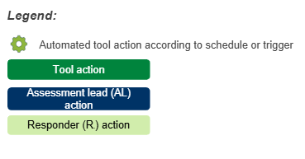
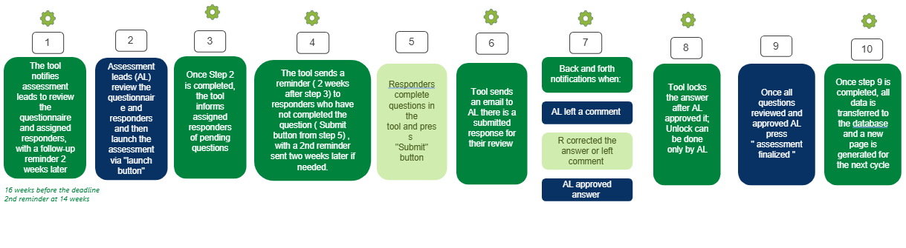During Step 4 execution tool cc AL assigned to the country.
In Step 10, the “New Page” displays the most recently approved chapters, sub-chapters, questions, assigned responders, and current-year approved responses, serving as a basis for next year’s “Assessment launch.”
Reference table with deadline and ALs is in 4.1 chapter of this document.

5. Database & Data Management

5.1 Database Structure
The database shall store data by assessment year, country, question ID, question itself, response, and who is the responder.
Attachments be stored in related question.
The system shall support Excel extraction per country, entity and assessment year.

5.2 Historical Data
All responses from previous years shall remain read-only and Excel extraction.

5.4 Data Transfer & Archive
Once an assessment is finalized, data shall be transferred to a read-only archive page where approved responses are visible for reference in future assessments.

6. Reporting potential
Tool provides the following report per BU & Entity or Country:
- General statuses: not started, in progress, delayed, completed:
1.1. Not started: tool is waiting for the start trigger, “Launch assessment” button not yet activated by AL

1.2. In progress: start triggered, “Launch assessment” button activated by AL
- Status “In progress” completion rate formula: (total of approved questions * 100) / total quantity of questions in questionnaire

1.3. Delayed: deadline passed, AL didn’t press button “Assessment finalized”

1.4. Completed: “Assessment finalized” button activated by AL.

2. Assessments Start date & End date overview
3. Assessments to be shared with authorities? Yes, No
4. Excellence Tag responsible for country
5. Any issues, risks, blocks preventing us from delivering the assessment on time

7. Version History
Effective Date | Version Number | Version Description | Author | Co - Author | Approver | Final Approval Date
23, Apr 2026 | 1.0 | Initial release | Daria Kovalenko | Nishant Grover | Luis Loaiza | TBD

